

**CONFIDENTIAL**

December 11th, 2025

20

**Proposal Document**

Interactive Quiz Web App for Monaco Conference

Version 1.2

**DISCLAIMER**

This document is submitted with the explicit understanding that the contents are confidential and would not be divulged to any third party without prior written consent from Dotsquares Ltd. Services are supplied according to our terms and conditions <http://www.dotsquares.com/terms>

**DISCLAIMER**

This document is submitted with the explicit understanding that the contents are confidential and would not be divulged to any third party without prior written consent from Dotsquares Ltd. Services are supplied according to our terms and conditions <http://www.dotsquares.com/terms>

***Please don’t print me, it’s bad for the environment.***

|  |  |  |
| --- | --- | --- |
| This document outlines the general scope of your project based on our understanding of the requirements provided and discussions to date. |  | **Prepared For:** Rachel Sharp  **Lead ID:** 140541 |

|  |  |  |
| --- | --- | --- |
| ocument outlines the general scope of your project based on our understanding of the requirements provided and discussions to date. |  | **Prepared For: Toon**  **Lead Id: 123705** |

**DISCLAIMER**

This document is submitted with the explicit understanding that the contents are confidential and would not be divulged to any third party without prior written consent from Dotsquares Ltd. Services are supplied according to our terms and conditions <http://www.dotsquares.com/terms>

**DISCLAIMER**

This document is submitted with the explicit understanding that the contents are confidential and would not be divulged to any third party without prior written consent from Dotsquares Ltd. Services are supplied according to our terms and conditions <http://www.dotsquares.com/terms>

**DISCLAIMER**

This document is submitted with the explicit understanding that the contents are confidential and would not be divulged to any third party without prior written consent from Dotsquares Ltd. Services are supplied according to our terms and conditions <http://www.dotsquares.com/terms>

**DISCLAIMER**

This document is submitted with the explicit understanding that the contents are confidential and would not be divulged to any third party without prior written consent from Dotsquares Ltd. Services are supplied according to our terms and conditions <http://www.dotsquares.com/terms>

**DISCLAIMER**

This document is submitted with the explicit understanding that the contents are confidential and would not be divulged to any third party without prior written consent from Dotsquares Ltd. Services are supplied according to our terms and conditions <http://www.dotsquares.com/terms>

**DISCLAIMER**

This document is submitted with the explicit understanding that the contents are confidential and would not be divulged to any third party without prior written consent from Dotsquares Ltd. Services are supplied according to our terms and conditions <http://www.dotsquares.com/terms>

**DISCLAIMER**

This document is submitted with the explicit understanding that the contents are confidential and would not be divulged to any third party without prior written consent from Dotsquares Ltd. Services are supplied according to our terms and conditions <http://www.dotsquares.com/terms>

**DISCLAIMER**

This document is submitted with the explicit understanding that the contents are confidential and would not be divulged to any third party without prior written consent from Dotsquares Ltd. Services are supplied according to our terms and conditions <http://www.dotsquares.com/terms>



**Defining Entertainment and Delivering It to the World…**

**Defining Entertainment and Delivering It to the World…**





AR DEVELOPMENT

AR DEVELOPMENT

IMMERSIVE HEALTH CARE

IMMERSIVE HEALTH CARE

AUGMENTED SHOWCASE

AUGMENTED SHOWCASE

SMART GLASSES

SMART GLASSES

GESTURE BASED API

GESTURE BASED API

**40**

Inventive Studio has some of the most experienced and talented immersive technology specialists and developers in the industry. The diversity of the projects they have worked on has enhanced their experience to a degree where they can materialize even the most complex game ideas.

Inventive Studio has some of the most experienced and talented immersive technology specialists and developers in the industry. The diversity of the projects they have worked on has enhanced their experience to a degree where they can materialize even the most complex game ideas.

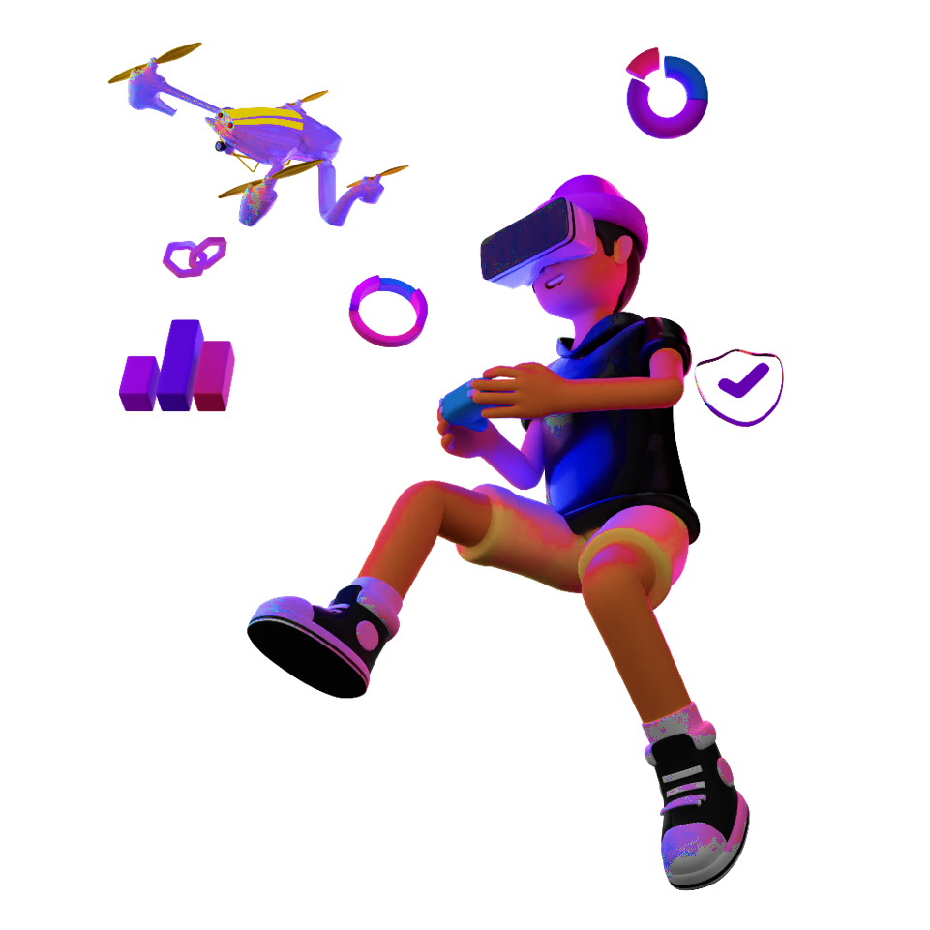

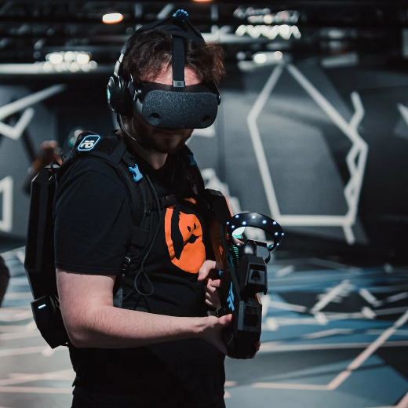





With a perfect blend of the most advanced development technologies and experienced developers, we cater to all your immersive and gaming app development requirements. We have years of experience in creating native and cross-platform solutions for our clients and are now able to transform any idea into reality with utmost precision and high-quality. Our developers are both skilled and experienced in developing 2D, 3D, and high-quality AR/VR apps for all compaitable platforms.

With a perfect blend of the most advanced development technologies and experienced developers, we cater to all your immersive and gaming app development requirements. We have years of experience in creating native and cross-platform solutions for our clients and are now able to transform any idea into reality with utmost precision and high-quality. Our developers are both skilled and experienced in developing 2D, 3D, and high quality AR/VR apps for all compaitable platforms.



**DEPLOYMENT**

**DEPLOYMENT**

**TESTING**

**TESTING**

**GAME DEVELOPMENT**

**GAME DEVELOPMENT**

**GAME DESIGN**

**GAME DESIGN**

**STORYBOARD**

**STORYBOARD**

**REQUIREMENT GATHERING**

**REQUIREMENT GATHERING**

**Our Process**

**Our Process**





## ***Table of******Contents***

Revision History 4

Project Description 5

Scope of Work 8

Implementation Estimates 14

Payment Schedule 14

Resource Utilization 15

Technology Specifications 15

Client Receivables 16

Deliverables 16

Important Points 17

Change Request Process 17

Software Development Life Cycle: 18

CMMI 23

Our clients 26

# Revision History

|  |  |  |  |  |
| --- | --- | --- | --- | --- |
| **Version** | **Date** | **Description** | **Prepared by** | **Reviewed by** |
| 1.0 | 01-12-2025 | Initial Understanding Document and Estimations | Varun Chaudhary | Mohit Kumar |
| 1.1 | 02-12-2025 | Amendments to the scope | Varun Chaudhary | Mohit Kumar |
| 1.2 | 11-12-2025 | Updated Scope of Work | Varun Chaudhary | Mohit Kumar |

**Purpose** of the Document

This document outlines the general scope of your project based on the requirements provided and discussions to date. The main objective at this stage is to ensure that all parties agree upon the general scope, budget and schedule of the project prior to commencing work on a time & materials basis.

**Clients are urged to ensure that all details contained within this document are clear and fully meet their requirements before any work commences. Timescales mentioned only cover the scope listed, if these changes, costs and timings will change accordingly.**

Once you are happy, we will progress into the next stages. This may include further detailing requirements and functionality or it may go straight into design/development. This will depend on the nature of the project.

# Project Description

Based on the client's requirements, this project will deliver a browser-based interactive "Where in the World?" quiz game designed specifically for a finance conference taking place in Monaco in late January. The experience will run as a microsite that allows all delegates to participate instantly through a QR code, without installing any application or requiring formal registration.

A clue will appear on the main event screen, indicating a country somewhere in the world. Delegates will open the microsite on their mobile phones or tablets, **enter a nickname to join, and select their answer from multiple-choice options (A, B, C, or D).** Once all participants have submitted their responses, or once the round timer has ended, the host will reveal the correct answer on the big screen along with a world map showing the location. After each round, **a live leaderboard displaying the top 10 players** will be shown based on their scores.

The content for each round — including clues, answer options, correct answers, and the number of rounds — will be predefined and supplied by the client. Since the purpose is to run the game for a single event, all questions and correct answers will be set in advance and do not require an admin panel for management.

The system will include a simple host interface to control the flow of the session, move between rounds, trigger the reveal of results, display the correct answer with the map, and show the leaderboard. Delegates will enter only a nickname to participate, keeping the experience simple and accessible.

This solution focuses on reliability and ease of access during the live event, supporting a large audience (potentially 150–300 participants) simultaneously. The scoring system will award points for correct answers, with **faster responses ranked higher in case of a tie.** The final experience will be fast, lightweight, visually consistent with the event branding, and designed to avoid technical risk on the day of the conference.

**Purpose** **of** **the** **Project**

The purpose of this project is to create a simple, reliable, and fully browser-based interactive game that enhances audience engagement during a finance conference in Monaco. The client aims to run a real-time “Where in the World?” country-guessing challenge where delegates participate instantly using their mobile devices, without the need for app installation, registration, or sharing personal information.

The solution is intended to provide a seamless live experience that scales to a large audience, supports fast participation, and avoids technical complexity on the day of the event. By keeping all content predefined and static, the focus remains on delivering a polished, stable, and accessible interaction that can be run by the conference host with minimal effort.

**Key Features**

* **QR-Based** **Instant Access**
  + Delegates will join the game by scanning a QR code displayed on the main screen, opening a mobile-optimised browser experience.
* **Nickname Entry (NEW)**
  + Upon joining, each delegate will enter a nickname (display name) to identify themselves on the leaderboard. No email, phone number, or personal details will be required.
* **Multiple Choice Answers (NEW)**
  + Each question will present four answer options (A, B, C, D) on the player's mobile device. The delegate will select one option before the timer ends.
* **Answer Change Allowed**
  + Delegates will be able to change their selected option until the timer runs out. The last selected answer will be submitted automatically.
* **Static World Map on Big Screen**
  + A custom-designed, static world map will be displayed on the big screen when revealing the correct answer. The map will highlight the correct country location.
* **Live Leaderboard - Top 10 (NEW)**
  + After each round, the big screen will display the top 10 players based on their cumulative scores. This creates a competitive element and encourages continued participation.
* **Admin Questions Management** 
  + Admin will be able to add, edit, and remove questions & answers
* **Speed-Based Tie Breaker (NEW)**
  + If two or more players have the same score, the player who answered faster will be ranked higher on the leaderboard.
* **Predefined Questions and Answers**
  + All clues, answer options, correct answers, and round content will be supplied in advance by the client.
* **Host-Controlled** **Session Flow**
  + A simple host interface will allow the presenter to move between rounds/next question, trigger the reveal of results, and display correct answers on the main event screen.
* **Large-Audience** **Support**
  + The system will support approximately 150–300 concurrent participants, ensuring smooth responsiveness during peak load.

**Scope** of Work

This section enumerates all the features outline for development within the scope of this project.

1. User Types

* **Host / Presenter**
  + The Host is responsible for running the live session during the conference. They will control the flow of the game, move between rounds, display clues on the main event screen, and reveal results.
  + Key actions:
    - Open the host panel
    - Start each round
    - Display the clue on the main screen
    - Trigger the result reveal
    - Move to the next round

* **Participant / Delegate** 
  + Uses the second tablet connected via Wi-Fi Direct or local network.
  + The Participant is any attendee at the event using their mobile device or tablet to play the game. They join anonymously via a QR code and interact only with the mobile browser interface.
  + Key actions:
    - Scan the QR code to join
    - Enter a nickname
    - Select an answer (A, B, C, or D)
    - Change answer if needed before the timer ends
    - View the leaderboard on the big screen

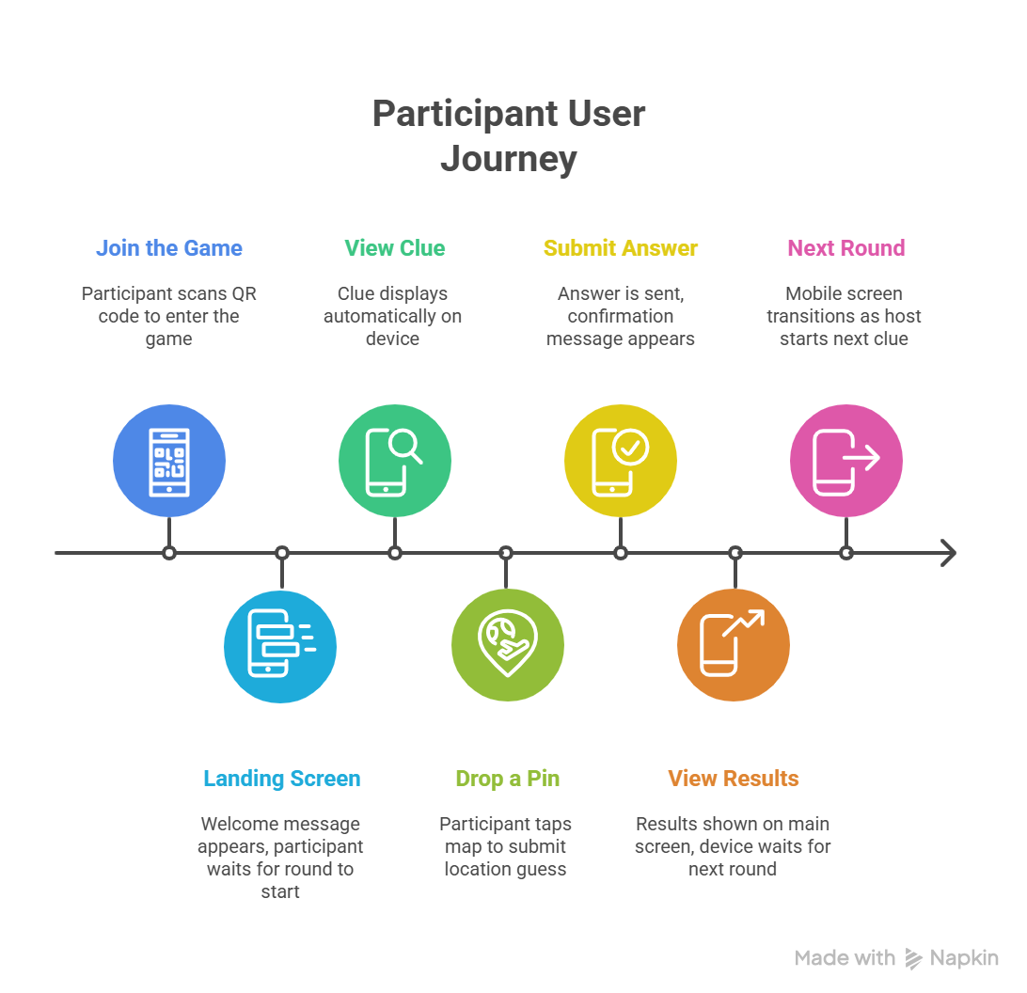

1. Microsite Features
2. QR Landing Page (Participant – Mobile)

* The user will scan the QR code shown on the big screen.
* User will be redirected to a mobile-optimised landing page.
* User will see a short welcome message.
  + User will see a simple “Waiting for host to begin” state.
* The user will see an input field to enter their nickname.
* User will not enter any personal details.
* User will not register or sign in.
* Page will automatically move to the next screen when the host starts Round 1.

Screen: Landing Page of Big Screen

1. Clue + Answer Screen (Participant – Mobile)

* The user will see the clue text at the top of the screen.
* The user will see a countdown timer showing remaining time.
* The user will see four answer options displayed as buttons (A, B, C, D).
* The user will tap on one option to select it.
* The selected option will be highlighted.
* The user will be able to tap a different option to change their answer.
* The last selected option before the timer ends will be submitted automatically

Screen: Player Join Screen (Mobile)

1. Submission Waiting Screen (Participant – Mobile)

* User will see a waiting message after submitting.
* User will not be able to change their answer.
* Screen will auto-transition to the next round when host moves forward.

1. Host Dashboard – Home (Host – Laptop)

* Host will open a secure URL on a laptop.
* Host will see a simple list of rounds (Round 1, Round 2, etc.).
* Host will see options: “Start Round”, “Show Clue”, “Reveal Results”, “Next Round”.
* The host screen will be cast or mirrored to the main event display, allowing the clue and results to be shown to all delegates.

Screen: Host Control Panel (Desktop/Laptop)

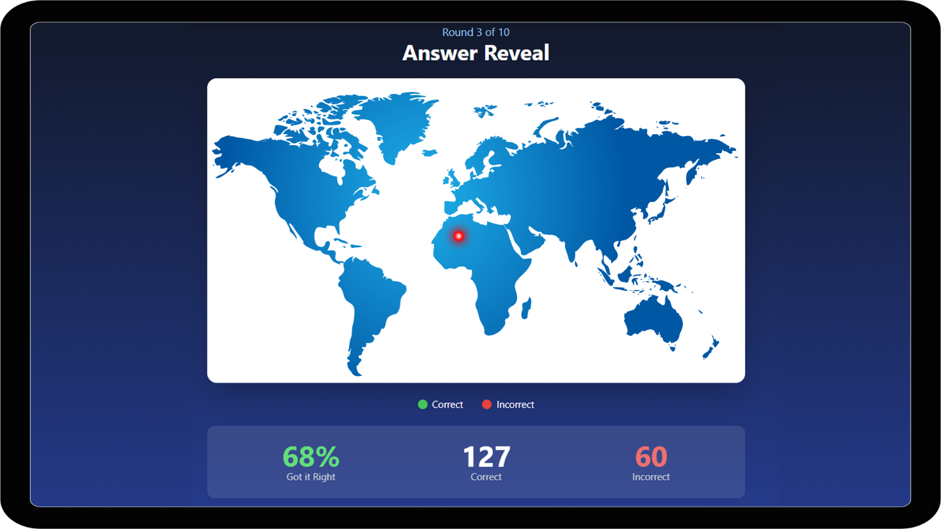

Screen: Big Screen - Results Summary (Projector View)

1. Host Dashboard – Round Control (Host – Laptop)

* Host will click “Start Round”.
* Host will click “Display Clue” which shows the clue on the big screen.
* Host will see a simple counter of how many responses have been submitted (e.g., “145/200 answers received”).
* Host will wait for enough submissions or for a set timer.
* Host will then click “Reveal Results”.

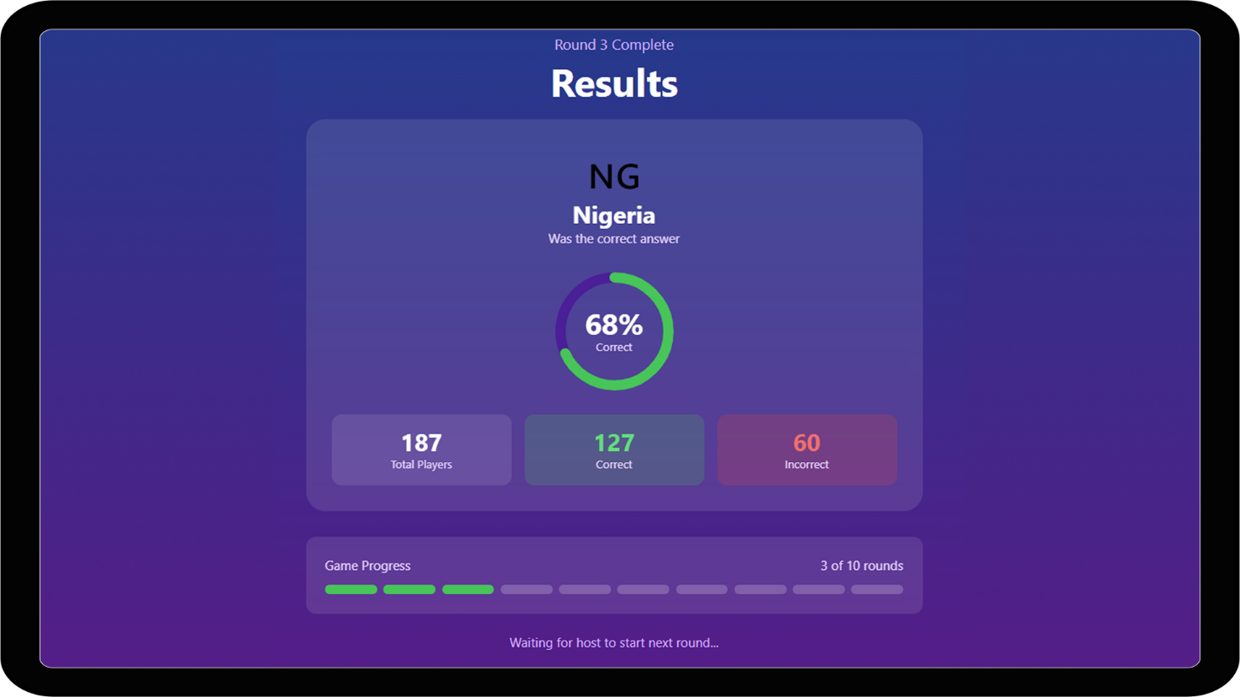

1. Leaderboard Control (NEW)

* The host will click "Show Leaderboard" to display the top 10 players.
* The host will see the top 10 players ranked by score.
* The host will click "Next Round" to proceed.
* After the final round, the host will click "End Game" to show final standings.

**Implementation** Estimates

|  |  |
| --- | --- |
| Estimated Delivery Timeline *(with multiple resources)* | **3.8 Weeks** |
| Estimated Cost *(Black Friday Offer)* | **£6232 + VAT** |

The above Estimate(s) are valid for 30 days from the date of issue

***\*\*\*Dotsquares offers a 30-Day Warranty Period post completion, with any bugs/issues being resolved at no additional cost within the period\*\*\****

# Payment Schedule

**Option 1: Fortnightly/Bi-Weekly**

|  |  |
| --- | --- |
| **Duration** | **Amount *(exc VAT)*** |
| Week 0-2 | £3280 |
| Week 2-3.8 | £2952 |

**Option 2: Monthly**

|  |  |
| --- | --- |
| **Duration** | **Amount *(exc VAT)*** |
| Week 0-3.8 | £6232 |

# Resource Utilization

|  |  |  |
| --- | --- | --- |
| **S.no.** | **Profile** | **Nature of engagement** |
| 1. | One Frontend Developer | Full Time |
| 2. | One Backend Developer | Partial |
| 3. | One Designer | Partial |
| 4. | One Business Analyst/ Project Manager | Partial |
| 5. | One Quality Analyst | Partial |

# Technology Specifications

|  |  |
| --- | --- |
| **Component** | **Technology** |
| Platform | Mobile & Tablet Browsers |
| Frontend Development | React JS |
| Backend Development | Laravel/Node.js |
| Real-Time Communication | WebSocket’s |
| Programming Language | JavaScript |
| Design Tools | Figma, Adobe Photoshop |

**We have provided our technology suggestions based on the requirements provided and our experience with the best way of realising these. If you have any specific technical requirements or would like us to explore other options, please just get in touch to let us know.**

# Client Receivables

|  |  |  |
| --- | --- | --- |
| **S.no** | **Receivables** | **Estimated Delivery** |
| 1. | All the content for the website | The date will be mentioned when the project will be awarded. |
| 2. | The client will provide branding assets (If any), any official logo, specific fonts, or colour palettes to be used in the user interface. | The date will be mentioned when the project will be awarded. |
| 3. | Any 3rd Party API/SDK will be provided by the client | The date will be mentioned when the project will be awarded. |

# Deliverables

|  |  |  |
| --- | --- | --- |
| **S.no** | **Deliverable** | **Estimated Delivery** |
| 1. | Delivery schedule by BA / PM*(link) | The date will be mentioned when the project will be awarded. |
| 2. | Test Cases by QA* (link) | The date will be mentioned when the project will be awarded. |
| 3. | Project Plan by BA / PM* (link) | The date will be mentioned when the project will be awarded. |
| 4. | Source Code | The date will be mentioned when the project will be awarded. |

# Important Points

1. Time estimation may vary if any further functionality is required by you, other than what is mentioned in the above document. Responding to the query may lead to changes in the estimation.
2. We will provide you with two iterations for every UI/UX design, after that, if you want any more iterations, we will consider it as a new requirement, and time may vary.
3. The proposed UI/UX displays in this document are simply mock-ups; the actual screens may differ.
4. The application will be developed in English for now.

# Change Request Process

**We understand that during the process of Software Development, the client may need to add or alter requirements due to changing market needs. To ensure that the clients can get the best products developed, we at Dotsquares have an established CR process that integrates these changes into ongoing development seamlessly.**

**What is a CR?**

A change request is a proposal to alter a product or system, often brought up by the client. During a project, this can happen when a client wants to change or alter the agreed-upon deliverables. Thus, any requirement or work not mentioned under the Scope of Work section in this document will constitute a change request.

Our CR process follows a set of predefined steps as shown below

**Software** Development Life Cycle:

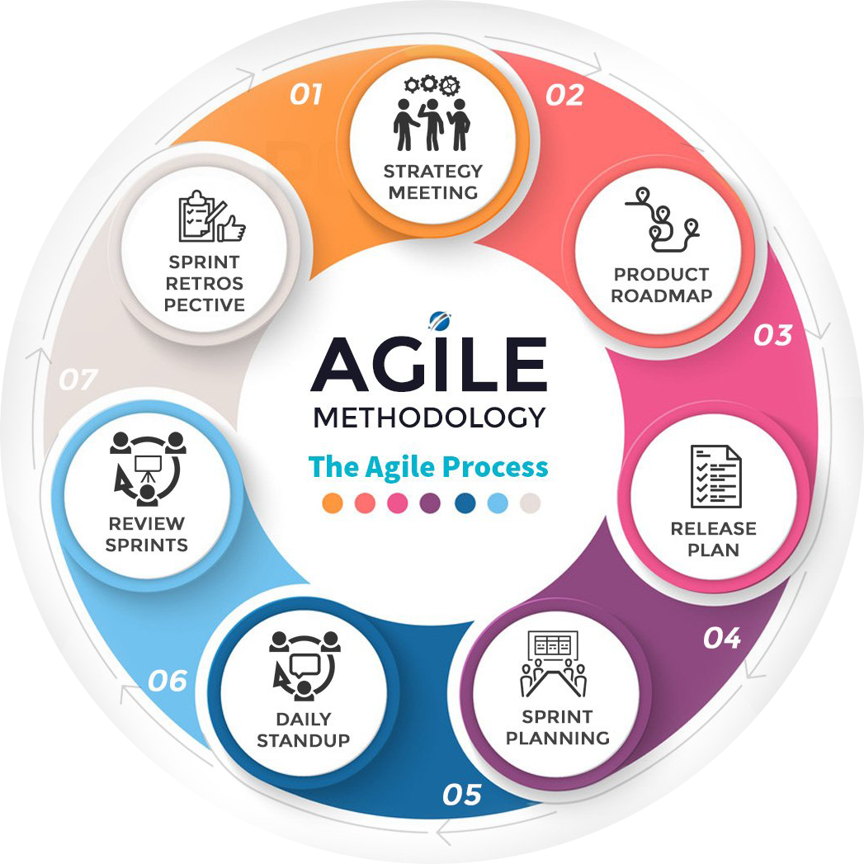

**Why is SDLC time mandatory?**

Dotsquares is a CMMi L3 Process-based organization, so every process has been defined in the organization, and our project managers always try to control all project constraints.

As per the diagram, every project has a few constraints to control the project, such as scope, time, cost, quality, risks, and resources, if any constraints go beyond the limit or failed that project may get failed. The project manager and their supporting team control all the constraints from initiation to closing of the project to make sure that we deliver the best quality product and services to our client.

**Note: - Project manager, technical lead, and Quality analyst are involved to control the project constraints through**

* **Project Manager** - Project Planning, SRS Document, Sprint Planning, Team Meetings, Communication, UAT, etc.
* **Technical Lead** - Database Schema Designs, System Design Documents, Code Review, Unit Testing, Technical Assistance to Development Team, Team Meetings, Technical Communication, UAT, etc.
* **Quality Analyst** - Functional Testing, Create Test Cases, Test Cases Execution, System Testing, Regression Testing, Non-Functional Testing, Browser Compatibility, Responsive Testing

**This will be our project management process in steps:**

* **Kick-off Meeting**: As soon as the project is on board, we take a kick-off meeting on the very first day with all the team members’ involved Project manager, developer (s), Designer, and Client. The agenda of this meeting is to make sure all the stakeholders involved are on the same ground in terms of requirements, discuss the details required like payment gateway details and API credentials, and discuss the time for the regular update meetings.
* **SRS**: This is the System Requirement Specification document that entails the complete requirement in utmost detail and the acceptance criteria. This is a more polished version of the scope document that we share at the time of estimation. SRS is complete in approx. 2 days.
* **Design**: Design and SRS start from day one simultaneously. We will provide you with 2 iterations for every page design, after that, if you want any more iterations, then we will consider it as a new requirement, and time may vary.
* **Development**: Development also starts from day one, but while the PM is working on SRS, the development team works on setting up the development environment, staging/testing server so the client can view the regular updates, Database design, etc., and once the SRS completes (SRS completes in approx. 2 days) the team works on the project as specified in the SRS.
* **Client engagement and communication**: Dotsquares has its system to maintain proper communication with clients which is DSP (Dotsquares Projects). Any of the team members can create different threads in DSP, and other people involved can respond. Each message posted on DSP sends an e-mail to all the people involved to keep them up to date. You can also connect with the project manager on Skype or call in case of any queries or doubts.
* **Updates**: The team will share daily updates about the work they have done on the day and post the message on DSP. As soon as the concerned module is completed, the team will put it on the staging server so the client can review the work done and share their feedback. The team will work on the feedback accordingly. There will be multiple releases during the project development, so the client is aware of the system.

**Additional** Services

Support & Maintenance

At an additional cost, we offer support and maintenance under the following options:

**Bucket**

* It is a good option when ad-hoc support is required.
* The client can purchase 20/40/60 hours on a pre-pay basis.
* The client can utilize the purchased hours when required.
* There will be no monthly fees or recurring contacts.
* Only the time used will be removed from the bucket – in amounts as small as 15 Minutes.
* The bucket is kept with the developer/PM & authorization is not required from our accounts.
* Team & Accounts will keep you posted on Bucket hours, and the same will be shared on our Project Management System.
* You can top up the bucket with the same or fewer hours when purchased hours are exhausted.

**Retainer**

* It’s a good option when a certain number of hours of support is required monthly, and our 24X7 support is required.
* No contracts. The engagement can be terminated at any time.
* The day-to-day activity log of the allocated members will be shared with you via our Project Management System.

**Warranty**

* If any bug occurs or any feature is not working in the game, we will resolve that issue within 30 days of completing the project. If you want any additional features, then we will estimate you accordingly.

We can also design a custom support maintenance plan to suit your business and project requirements. To find out which plan is more suited for your project, please contact your Project Manager.

**Development** Process

|  |  |
| --- | --- |
| Project Management Tool  Dotsquares will provide free access to DS Projects our project management and collaboration platform for project planning, communication, and tracking.   * Daily updates provided * Keeps digital track of conversations * Milestones and tasks for planning * Maintain task list for deliverables * E-mail notifications about updates & other activities | DSP |

Testing

We provide unit testing services for your project as a standard package. Unit testing is completed by the developer during the development cycle. We ensure all the software code blocks (paths) are executed at least once and produce the desired results.

|  |  |  |
| --- | --- | --- |
| Environment  Where possible, Dotsquares provides free-of-cost hosting during the project for you to test at your convenience. If the project dictates specific environmental requirements, a separate estimate will be provided for these.  When the project is finished and signed off, we ask you to choose a hosting provider and deploy it to the live environment. |  | Deployment  Dotsquares will deploy the complete solution for the project. Code can also be supplied directly to you or any repository account held.  Web-based developments will normally be transferred to your hosting account and put live as required. Mobile applications will be uploaded to the relevant App Store under your developer account. |

|  |  |  |
| --- | --- | --- |
| Warranty  Your software is delivered with a free warranty of 30 days. You must notify the team during the 30-day warranty period if you identify an error in the code/system/program. Once it has been agreed upon, Dotsquares will correct any errors made in the construction of the code/system program at no cost. Dotsquares reserves the right to define a bug/error. |  | Intellectual Property Rights  All the Intellectual Property created, written, developed, furnished, or produced by us during the term of the agreement/project, within the scope of the agreement or any applicable Statement of Work shall be the client’s exclusive property.  All the code base, assets, and documentation (if any) will be provided to you after development. |

**CMMI**

What our CMMI Maturity level rating means for you?

|  |  |  |
| --- | --- | --- |
|  | **Improved Quality**  - Well-defined processes limit opportunities for error.  - Smart supplier management ensures quality results.  - Strategic people management enables team members to develop skills that will help the  Organization succeeds. |  |
|  |  |  |
|  | **Decreased Costs and Enhanced Productivity**  - Streamlined processes allow teams to integrate and collaborate more efficiently.  - Standardized project management practices reduce redundancy and waste.  - Identifying skill gaps helps break down workflow bottlenecks. |  |
|  |  |  |
|  | **Higher User Satisfaction**  - Service delivery strategies strengthen weak User touch points.  - Elective product development instills User confidence.  - Project management practices help teams meet and manage User expectations. |  |
|  |  |  |
|  | **Improved On-Time Delivery**  - Field-tested project management standards keep work on schedule.  - Clear development processes reduce scope creep and deadline extensions.  - Careful vendor management mitigates supplier delays. |  |



**Our clients**

|  |
| --- |
|  |
|  |
|  |
|  |
|  |
|  |
|  |
|  |
|  |
|  |
|  |

